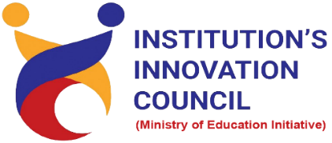

Institution's Innovation Council
Saurashtra University

Prototype / Process Design and Development – Prototyping

5 April 2022
At
Virtually on Webex
Saurashtra University Campus, Rajkot
Contents
Saurashtra University – IIC 2
Event Schedule 2
Event Registration Link 2
Brief about Event 3
Key Points 3
Outcome 3
About the Speaker/Chief Guest 4
Connect Us: 5

Saurashtra University – IIC
The university is dedicated to instruction, research, and extending knowledge to the public (public service). Ministry of Education (MoE), Govt. of India has established ‘MoE’s Innovation Cell (MIC)’ to systematically foster the culture of Innovation among all Higher Education Institutions (HEIs). The primary mandate of MIC is to encourage, inspire and nurture young students by supporting them to work with new ideas and transform them into prototypes while they are informative years. Saurashtra University is one the Organization that have constituted the IIC to foster the vision of MoE and be a part for the promotion and development of innovation ecosystem.

Event Schedule

12:00

Welcome

12:05

Awarness Session

01:00

Q n A

01:15

Closing Ceremony

Event Registration Link

bit.ly/PDD-IICSU

Brief about Event
We are organizing the Session on " Prototype / Process Design and Development – Prototyping " via Video Conferencing Mode to understand the process of Idea Generation and Prototype Development by Process Design, an informative session to understand the process design is organized by SUSEC & IIC - Saurashtra University
The webinar’s objective is to gain insights in a design thinking process to carry out some form of prototyping. This involves producing an early, inexpensive, and scaled down version of the product in order to reveal any problems with the current design. Prototyping offers designers the opportunity to bring their ideas to test the practicability of the current design, and to potentially investigate how a sample of users think and feel about a product.
After completion of the workshop, participants are able to acquire more knowledge on prototyping.
● Finding your product-market fit
● Adding value for end users
● Ways to attract investors
● How to refine your product designs

Key Points

During the session, below mentioned points were discussed:
- Factors effect product design
- Ethnography research
- Human factors and ergonomics
- Design thinking
- SWOT Analysis
- Six thinking hats
- Structuring your ideas
- Importance of prototype
- FAQ’s related to Prototype / Process Design and Development – Prototyping

Outcome
As per the event, various types of Prototype design, Importance of prototype and Idea selection criteria was understood by the speaker.
Also, as it was related to Product design and awareness creation, a basic knowledge of how to design product, how it works, how to develop prototype model, with various examples of product design and research etc.

About the Speaker/Chief Guest

Ms. Neha srivastava

Dy. Manager, R&D, Industrial Designer

Franke Faber India Private limited, Pune

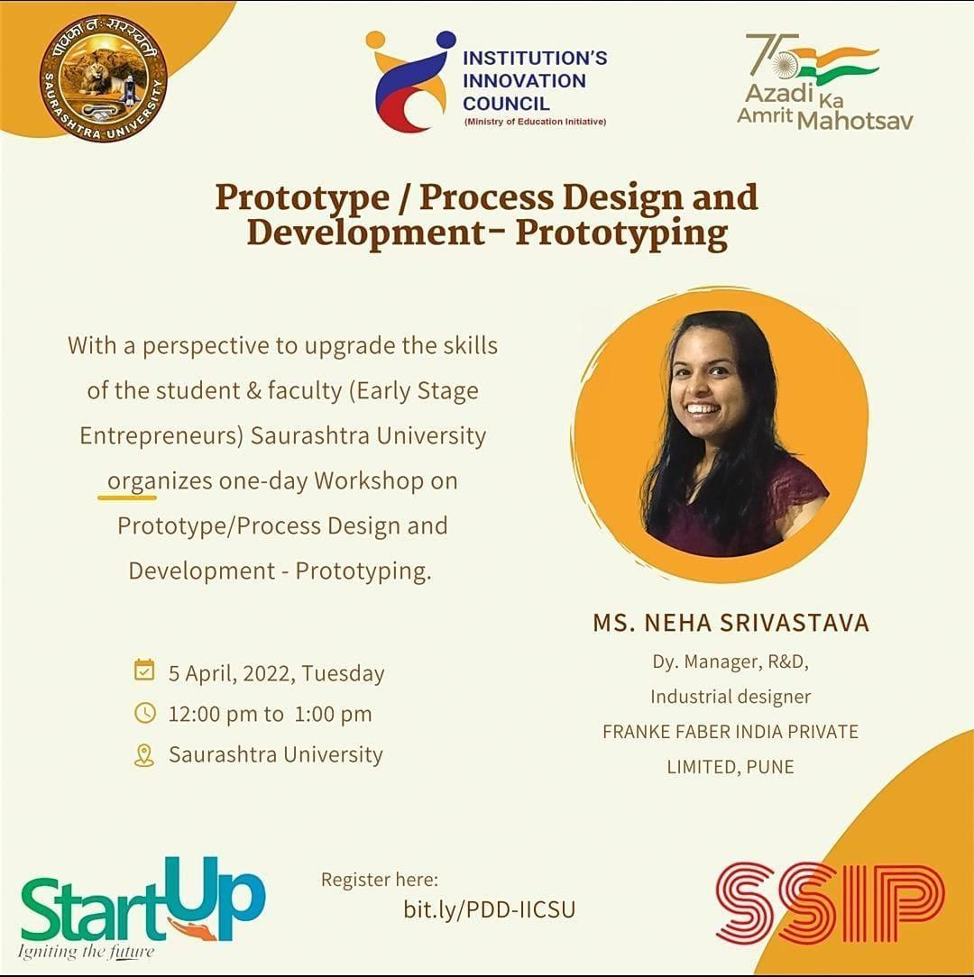
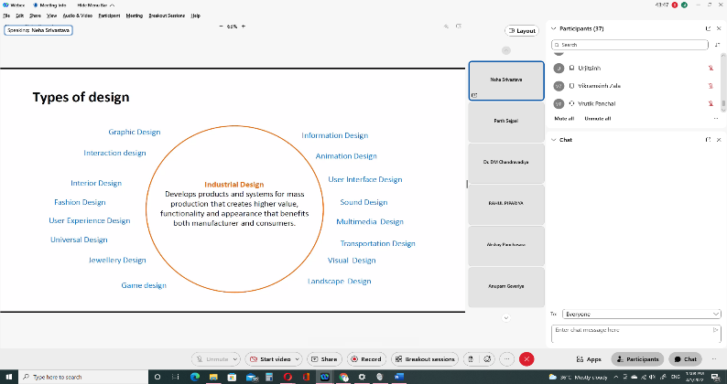
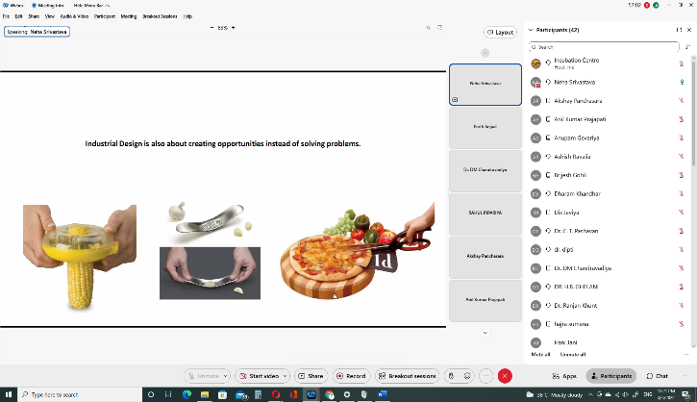

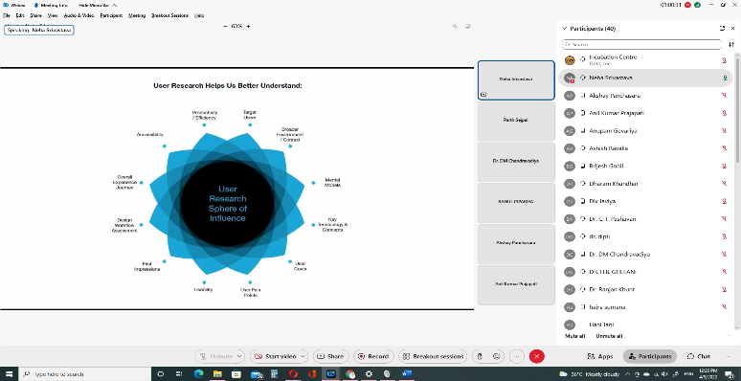
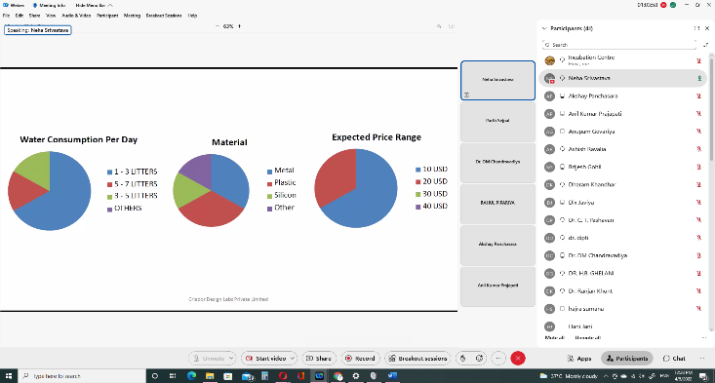

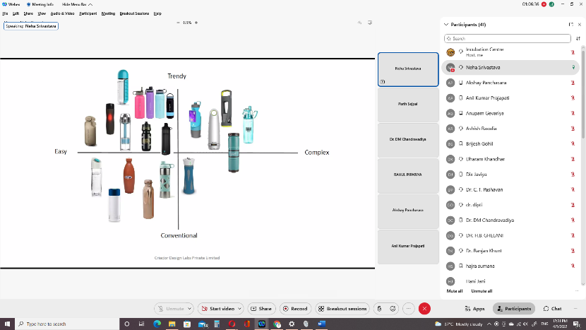
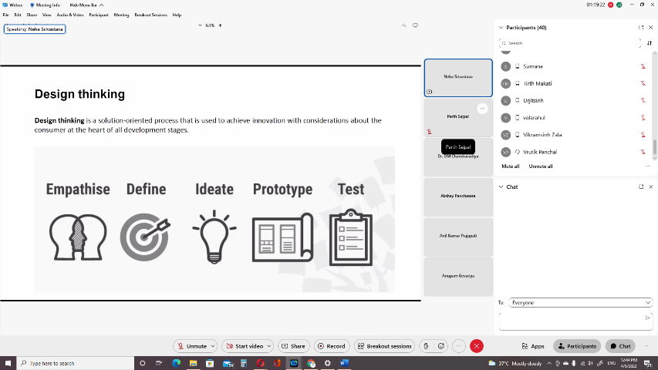
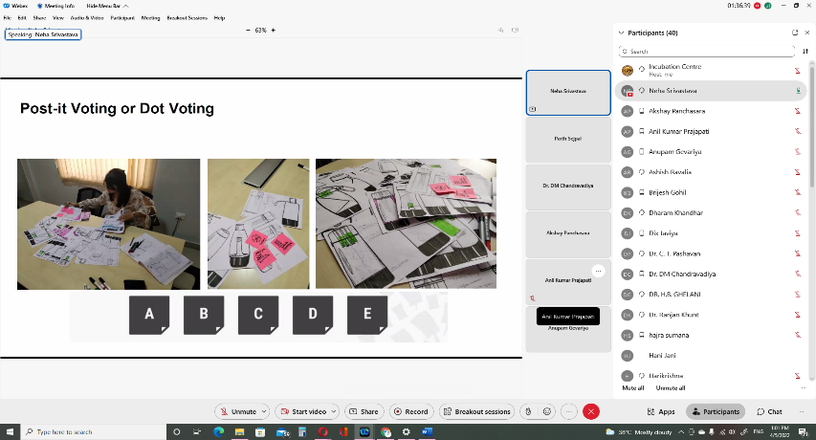

Connect Us:
https://www.linkedin.com/company/susec iic@sauuni.ac.in
https://www.facebook.com/iicsauuni bit.ly/SU-SSIP Location
https://www.instagram.com/susecrajkot

